Saudia Young photo:Andreas Hudertus Ilse
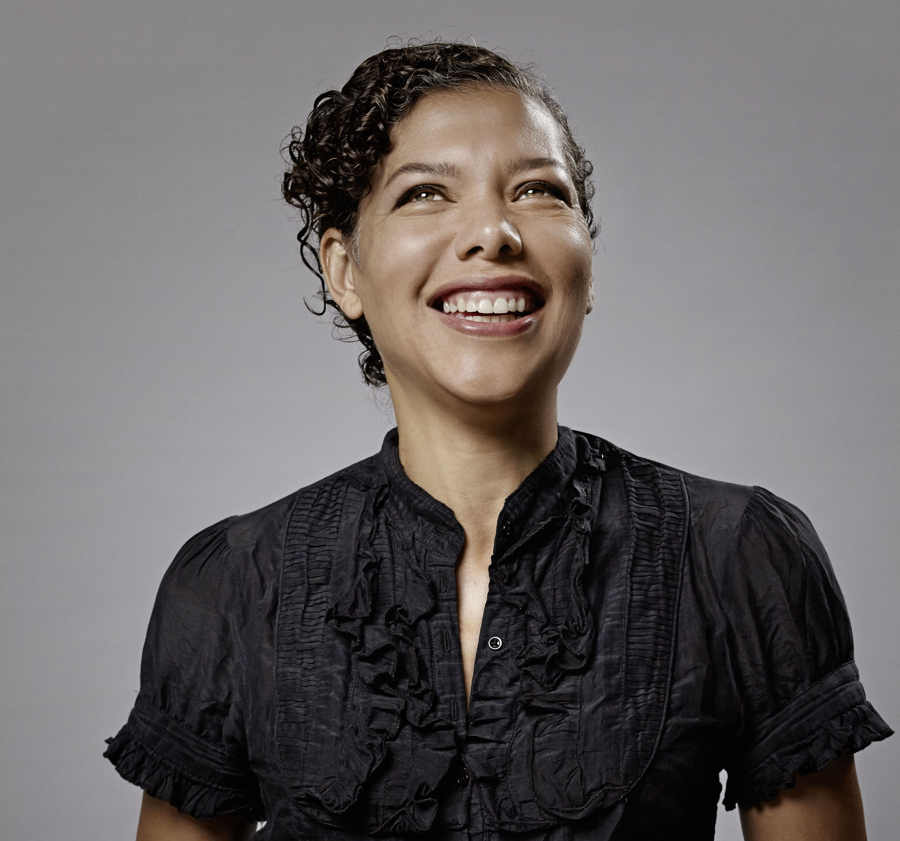
Oderbergerstr 40, Berlin, DE 10435 +491748379937
5’10” Size 6/8 Brown Hair Green Eyes Born: 6.6.62 U.S.A.

Film Role Project Company
2009 Lead/composer Perfect Love short DE
2004 Impatient Filters short US
2004 Sage The Long Weekend short US
1999 Anne Flushed ChickFlick US
1998 Rachael Go Down Moses Mercy Seat US
1993 Hooker Only the Strong Warner Bros.US
Theatre
2013 Co-founder Schwarze Liste Kabarett Acud,Berlin
2012 Co-Founder Lost Cabaret 3Schwestern,Berlin
2012 Chor Fatzer Festival Volksbuehne,Berlin
2008 Nun Joanna von Orléans Engelbrot,Berlin
2001 interview Spaulding Grey WTC Summer Stg, NY
1998 Bardoff Merry Wives of Windsor Met, LA
1997 Carol Road Here, NY
1997 Carol Freudian Slips Here, NY
1996 Jackie Midnight Zone Kraine, NY
1994 Solo show Sneaker Revolution Tribeca Lab, NY
Voice Over
2007-10 Oskar School for Vampires Hahn Films, DE
2008 Lorna Kings Road -Trailer Inspiria, UK /DE
2006 Girl 90db -Trailer bikinistudios, DE
Training:
Wynn Handman Scene Study, Meisner Carnegie Hall, NY
Voice:Alto/Mezzo Soprano

www/saudiayoung.com saudiauyoung@gmail.com

